CS 255 System Design Document Template
Brennen Lawson

This template lays out all the different sections that you need to complete for Project Two. Each section has guidance to prompt your thinking. You will need to continually reference the interview transcript as you work to make sure that you are addressing your client’s needs. There is no required length for the final document. Instead the goal is to complete each section based on what your client’s needs are. Remove this note when you are finished, and replace all bracketed text with the relevant information.

UML Diagrams

UML Use Case Diagram

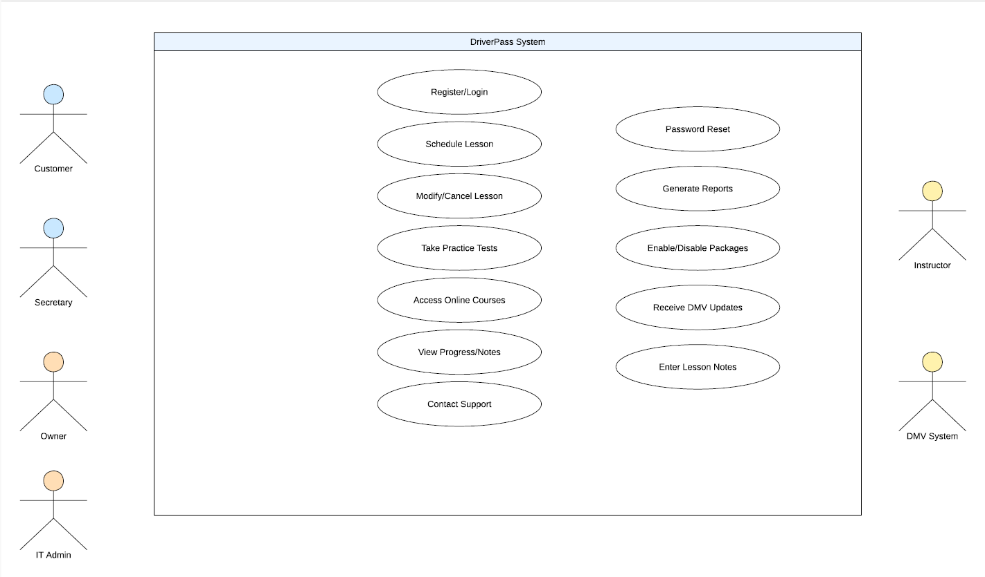

UML Activity Diagrams
Schedule/Manage Driving Lessons:
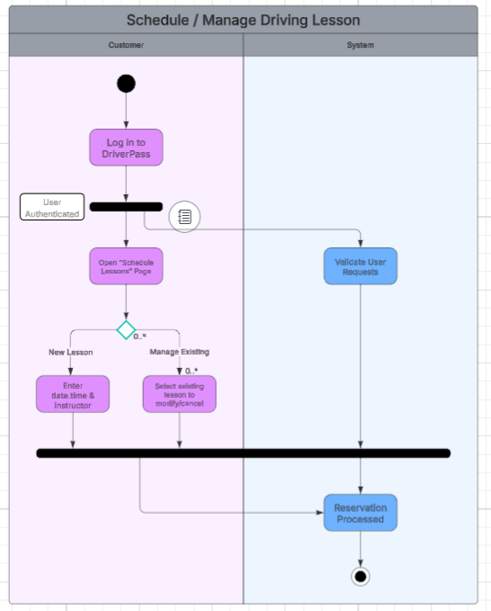

Take Online Practice Test:
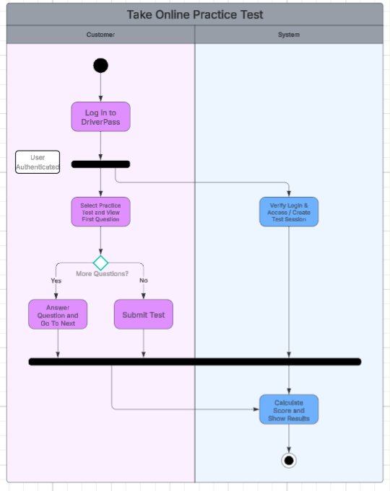

UML Sequence Diagram

Take Online Practice Test:
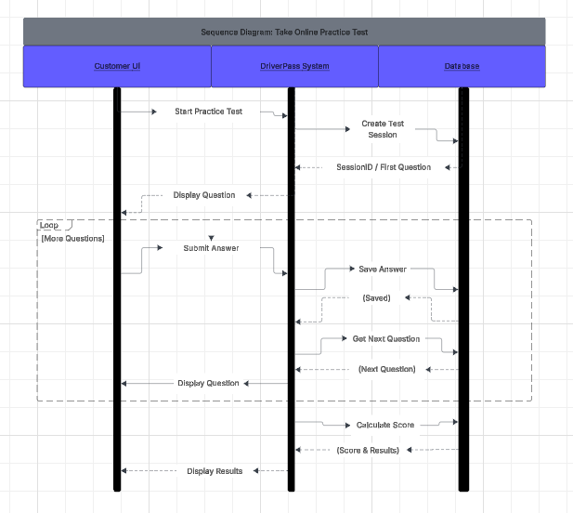

UML Class Diagram
System Class Diagram:
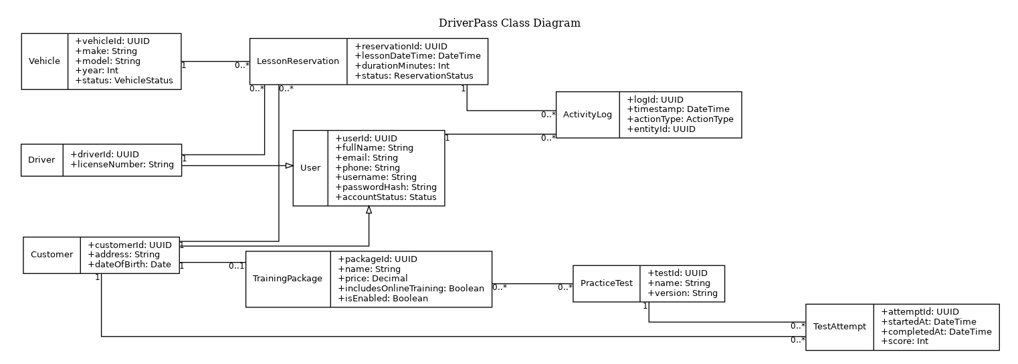

Technical Requirements

Hardware

Client Devices:

Any modern computer, smartphone, or tablet that is capable of running a major web browser and maintaining a stable internet connection, since the system is web/cloud-based.

Server Hardware:

The system should run on cloud-hosted infrastructure so that DriverPass doesn’t have to manage local backups/security.

Software

Application type:

A cloud-based web application that is accessible from desktops and mobile devices through standard browsers.

Back-end data storage:

A cloud-managed database that is able to store everything that the system needs to store, like customer info, reservations, practice tests, etc.

IT and Admin Capabilities:

Administrative tools that support password resets, disabling/managing accounts, managing role permissions, and other administrative needs for the system.

Infrastructure

Cloud Hosting:

The application and database should be hosted in the cloud with provider-managed redundancy and backups to prevent and mitigate data loss and reduce/eliminate local maintenance.

Performance:

All the pages and key parts of the system should be responsive and have minimal latency for the user, especially for things like scheduling and taking tests.

DMV Updates and Notifications:

The system needs to integrate a mechanism that is able to receive updates from the DMV and notify the staff and the users whenever rules or practice questions change.

Security

Authentication:

A unique username and password for login should be required. Also, multi-factor authentication would be a nice touch too.

Encrypted Communication:

All traffic between the client and the server must use HTTPS/TLS.

Brute-force Protection:

Whenever there are repeated failed login attempts on an account, the account should be locked or temporarily disabled. The account owner should also be notified of this either by text or email, and honestly, the account owner should be notified anyways whenever there is suspicious account activity.

Password Reset:

Users should have support for secure self-service password resets whenever they are needed.

Role-based Access Control:

Permissions should be enforced based on the role of the user.

Tools

Activity Logging:

Maintain logs that record who created, modified, and/or canceled reservations. The logs should have timestamps and user IDs for accountability.

Reporting:

Provide reporting that the owner can download and export to review performance and activity remotely.

